Lexi Maddox
Socy 335
Aging and the Family
9/24/2020

“Portrait of an Elder”

https://www.legacy.com/obituaries/name/rose-beck-obituary?pid=190167969
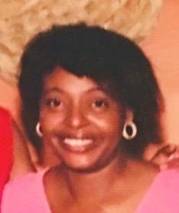
The person that I have selected is my Grandma Rose Beck. She is my grandma on my father's side. She was 73 years old when she passed away. I am not close to the majority of my family so this is pretty much the only person that I could choose and at least get some answers about. From what my parents tell me, I was very close to her when I was younger, but as she got older and started to have more and more health problems, I didn’t stay over as much. With me being so young, the type of health issues that she had, it sometimes scared me to go over her house. Years after, I was a teenager and I spent the majority of my time with friends, school, and basketball. It is a struggle picking 5 people to interview only because I am not so close with my family. I only have 1 older person over 65 to interview which is my grandma(Marionetta) on my moms side. The two middle aged people will be both of my parents(Tony & Monique); They are both older than 45. As far as picking a peer, none of my friends have ever met her nor do they know her so I will have to go with my older sister(Brittany). My parents and my sister should have answers to all of the questions I have sent them. I will be connecting them via email and facetime calls. I plan on recording our facetime calls so that I make sure I have all of their responses. My grandma will be a little harder to get in touch with. She does not have an iphone nor an email address that I can contact her with. It is hard to get in touch with her through text and over the phone. Hopefully I can find a way to get in touch with her because I am really interested in her insight on things if she has any.

